**House Rental Site Report**

Submitted in partial fulfilment of the requirement for the award of degree of

**Bachelor of Computer Applications**

**( Computer Application )**

**Submitted to :**

**LOVELY PROFESSIONAL UNIVERSITY**

**PHAGWARA, PUNJAB**



**SUBMITTED BY :-**

**Name of Student : Ashwani Pandey**

**Registration Number : 12211155**

**Roll no. : 16**

**Introduction**

In the age of digital transformation and convenience, the real estate industry has also embraced the online realm to streamline the process of renting houses. This project marks a significant step in this direction by presenting a meticulously crafted house rental website.

The objective of this project is to design and develop a user-friendly, visually appealing, and functional online platform for property seekers and landlords. Through the implementation of CSS (Cascading Style Sheets), we have enhanced the website's aesthetics and user experience, ensuring that it not only meets the basic requirements of a house rental platform but also stands out in terms of its design and usability.

Our project aims to simplify the house hunting process for tenants and property listing for landlords. Users will be able to search for their ideal rental property based on various criteria, view property details, and even contact property owners directly through the website.

This report will delve into the details of the project, including the design choices made using CSS, the technical aspects of the website, and the challenges encountered and overcome during the development process. It will also discuss user feedback and potential future enhancements to make this house rental platform even more robust and user-centric.

In conclusion, this house rental website project represents a significant milestone in the realm of digital real estate solutions. With the power of CSS, we've not only created a functional tool but also an aesthetically pleasing and user-friendly interface that is ready to transform the way people find and list rental properties.

**Technology used**

**HTML (Hypertext Markup Language)**

It is the markup language responsible for structuring the content and defining the layout of web pages. HTML provides a structured format for organizing information, making it accessible to both users and web browsers.

**Some key points about the usage of HTML in our project:**

1. **Content Structuring:** HTML is used to define the structure of each web page. It provides a hierarchy of elements, such as headings, paragraphs, lists, and divs, which help organize the content in a logical and meaningful way.
2. **Semantic Markup:** Semantic HTML elements are employed to describe the meaning of the content, enhancing accessibility and search engine optimization. Elements like <header>, <nav>, <main>, and <footer> are used to convey the purpose of specific sections.
3. **Forms and User Interaction**: HTML forms are utilized to facilitate user interactions, enabling property seekers to input their search criteria, submit contact forms, and provide feedback.
4. **Linking and Navigation:** Hyperlinks are used to connect different pages within the website, allowing users to easily navigate between property listings, search results, and additional resources.

**CSS (Cascading Style Sheets)**

It controls the layout, styling, and design aspects, ensuring a consistent and appealing appearance.

**Here's how CSS is applied in our project:**

1. **Styling and Layout:** CSS is employed to define the visual style of elements on the web pages, including fonts, colors, backgrounds, borders, and spacing. It provides a cohesive look and feel throughout the site.
2. **Responsive Design:** Using CSS media queries, the website's layout adapts to various screen sizes, guaranteeing that it remains visually appealing and functional on both desktop and mobile devices.
3. **Cross-Browser Compatibility:** CSS rules are crafted to ensure compatibility with multiple web browsers, so users have a consistent experience regardless of their choice of browser.

**Screenshots of projects:-**

**Welcome page of project**

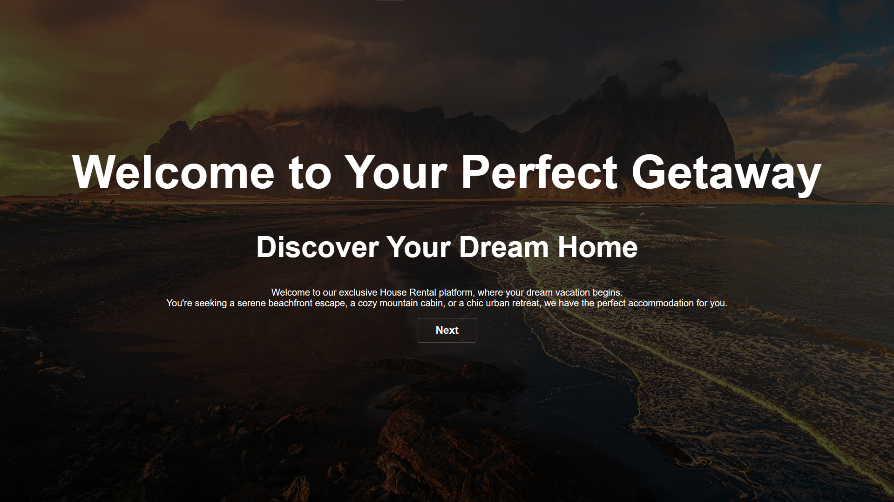

**Home page of project**

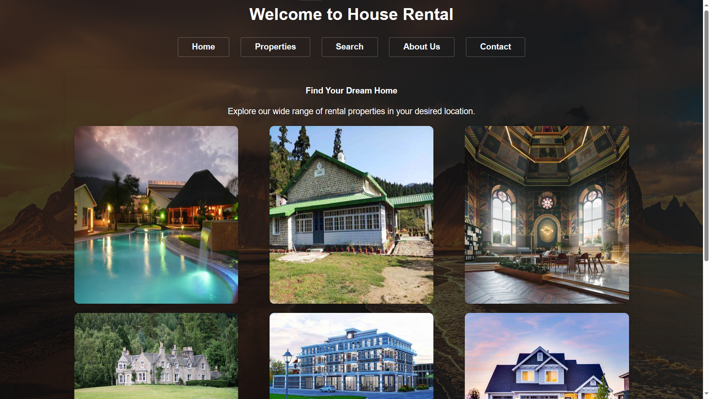

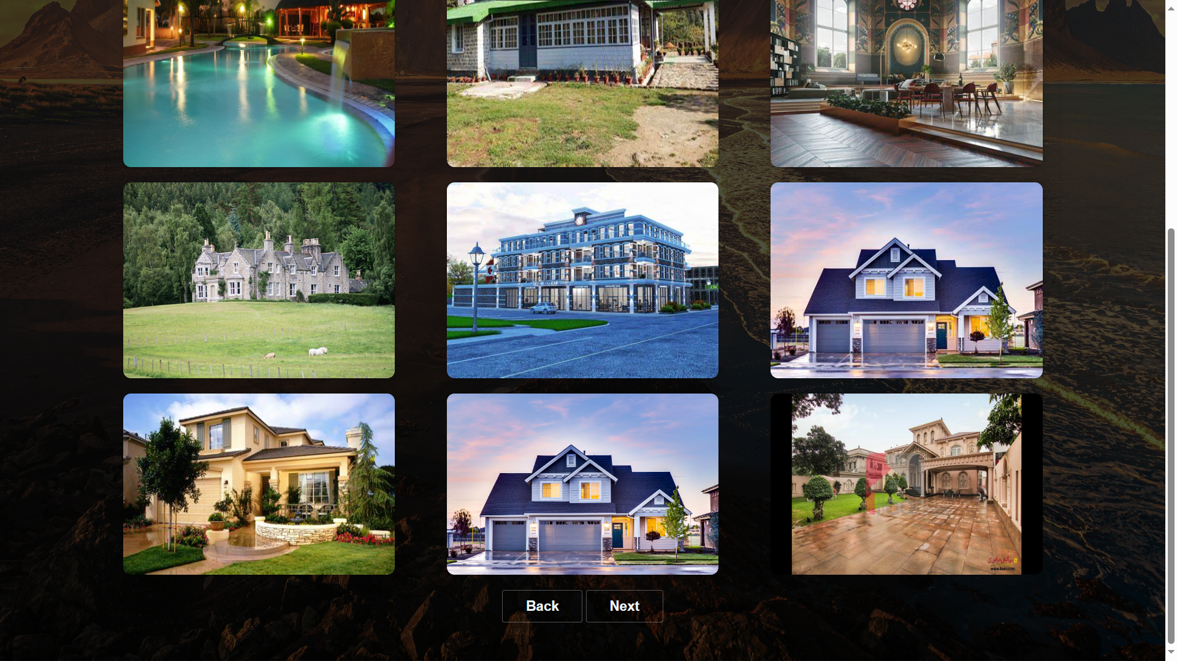

**House Rental Properties**

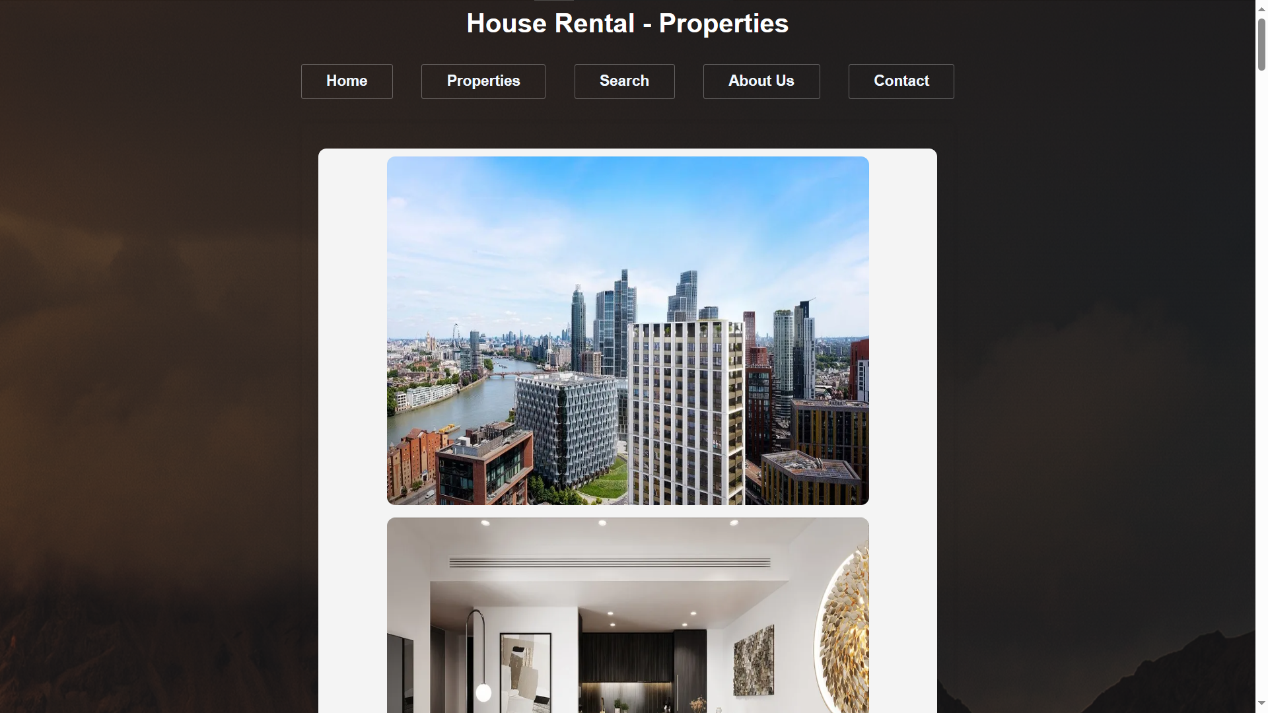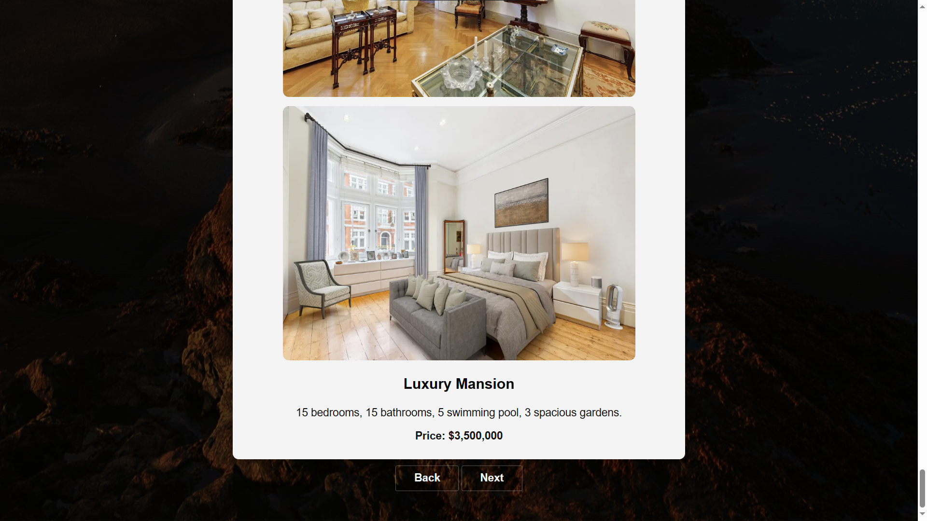

**House Search**

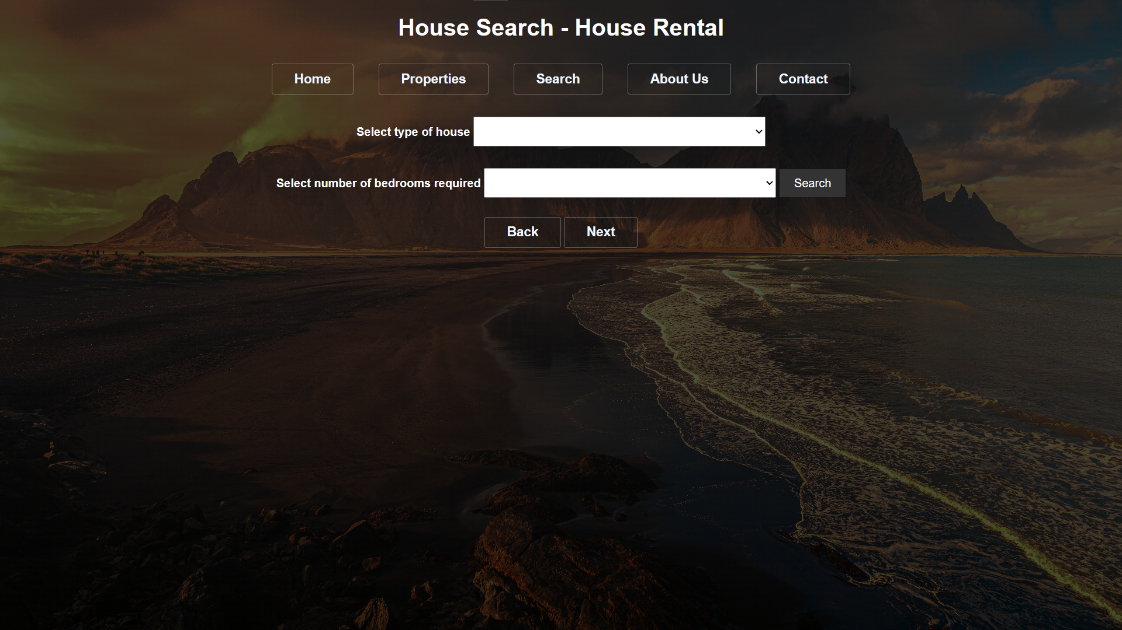

**About Us**

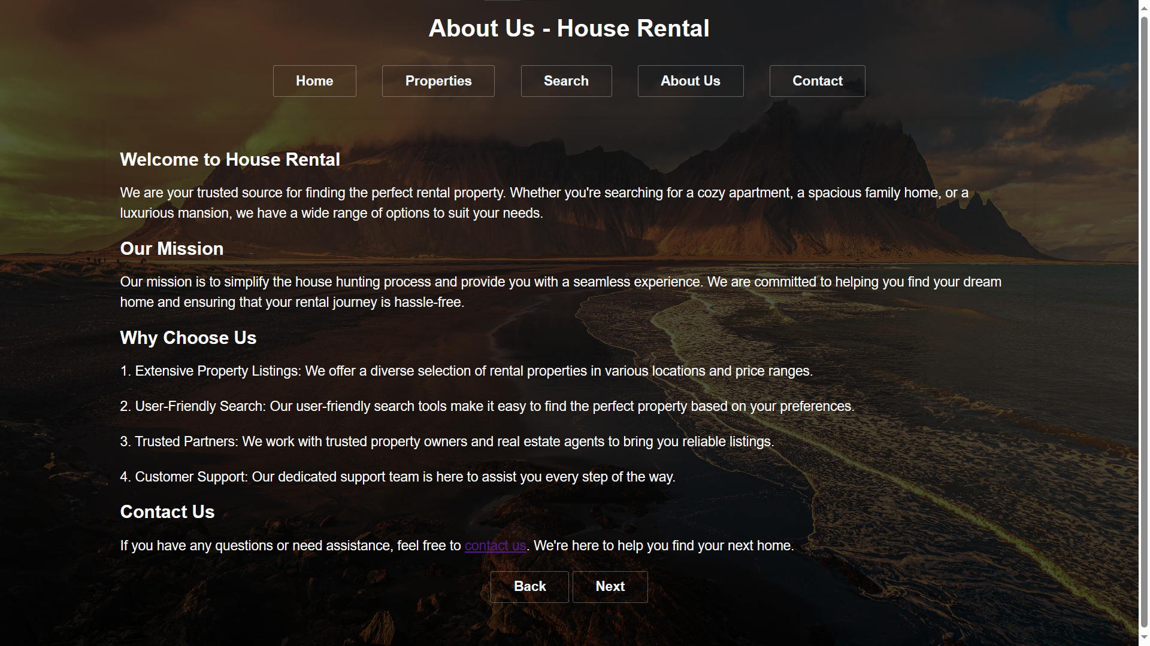

**Contact Us**

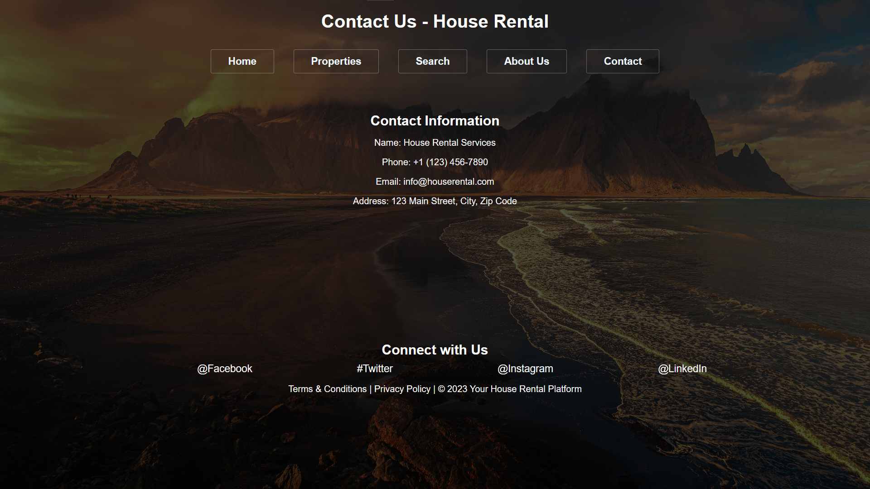

Various Functionalities

This project contains 5 webpages Home, Properties, Search, About Us, Contact Us.

* Home Page:

The Home Page serves as the landing page for your website. It typically includes a welcoming message and a brief overview of the services your platform offers.

Functionalities on the Home Page may include a dynamic image carousel showcasing featured properties, a search bar for quick property searches, and links or buttons that direct users to other key sections of the website.

* Properties Page:

The Properties Page is where users can browse and search for available rental properties. Key functionalities on this page include property listings with details like property type, location, price, and a brief description. Users can click on these listings to view more information about each property.

Filter and sorting options may be provided to help users narrow down their search based on criteria like location, property type, price range, and more.

Users may have the ability to save properties they're interested in and view their saved list later.

* Search Page:

The Search Page complements the Properties Page by offering an advanced search feature. Users can enter specific criteria, such as the number of bedrooms, bathrooms, and desired location, to refine their property search. Search results are displayed based on the entered criteria, allowing users to find properties that match their preferences more precisely.

* About Us Page:

The About Us Page provides information about your organization or company. It helps build trust and credibility with users. Functionality includes a description of your company's mission, values, history, and the team behind the project. You can also include any awards or recognition your company has received.

* Contact Us Page:

The Contact Us Page enables users to get in touch with your team or organization. It typically includes a contact form where users can enter their name, email, message, and other relevant details. Users can submit inquiries, feedback, or requests through contacts given in this page.

These functionalities are essential for creating a user-friendly and informative house rental website. They help users navigate the platform, search for properties, learn more about your company, and reach out to you for inquiries or assistance. The seamless integration of these features enhances the overall user experience and makes your website a valuable resource for both property seekers and landlords.